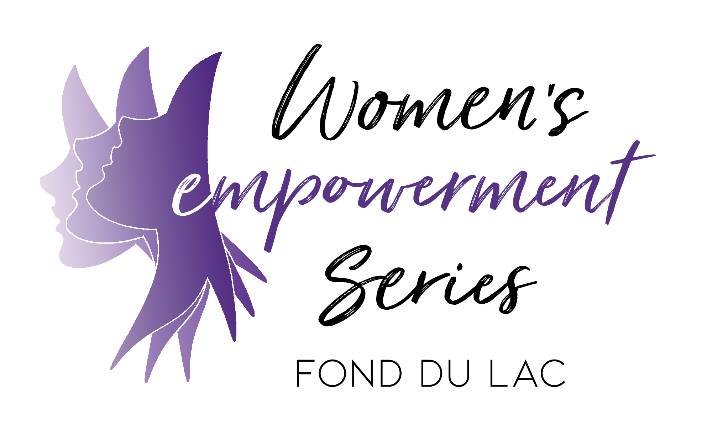
Participant Application - Spring 2020

Objective & Privacy Notice
The Women's Empowerment Series provides a 10-week program each year for 15 to 20 women from the area who have expressed a desire to better their lives by bettering themselves. Our weekly 3-hour class sessions are aimed at providing guidance, support, and resources to these women and empowering them to take control of their lives. Classes are taught by local professionals who generously donate their time by covering topics like trauma-informed parenting, education & resume building, health & fitness, self-care, domestic violence recognition & prevention, addiction, and more. In addition to these classes, we give participants the opportunity to build one-on-one relationships with volunteer mentors while simultaneously getting to know other local women in a safe, positive, and supportive environment. The series culminates in a makeover and a graduation ceremony where the hard work put forth is acknowledged and celebrated.

Applications are due by February 9th, 2020 at 4:30pm. Applicant interviews will be conducted in the months of January and February. Women are required to interview to be considered for the program. A committee member will reach out to all applicants regarding acceptance into the Series. Personal information will not be shared outside of the group, on social media, or with any companies partnering with this program without explicit consent from individuals.Participation in the Series is voluntary, but if accepted it is expected that each participant attend all 10 sessions.

Return applications to:
Women’s Empowerment Series
76 Western Ave.
Fond du Lac, WI 54935

Or email to info@womensempowermentseries.org

Personal Information
Name: __________________________________________________________________________________________________
Last First Middle

Date of Birth: __/__/___ Home Address: _____________________________________________________________________

Email Address: ___________________________________________ Phone Number: _________________________________

Best Way to Contact (circle): Email Phone Best Time to Contact: _________________________________________

Occupation: _______________________________________________________________________________________

Race/ethnicity (circle): White/Caucasian Black/African American American Indian/Native American Asian or Pacific Islander

Hispanic/Latina Multiracial Prefer not to answer Unknown

Children:
Name:___________________________________________________ | Date of Birth: __/__/___ | Gender:__________
Name:___________________________________________________ | Date of Birth: __/__/___ | Gender:__________
Name:___________________________________________________ | Date of Birth: __/__/___ | Gender:__________
Name:___________________________________________________ | Date of Birth: __/__/___ | Gender:__________
Name:___________________________________________________ | Date of Birth: __/__/___ | Gender:__________

Will you need childcare during classes? Yes No Unsure
(your answer to this question will not impact acceptance to program)

Will you need transportation to/from classes? Yes No Unsure
(your answer to this question will not impact acceptance to program)

Your T-Shirt Size: Small Medium Large X-Large 2X-Large 3X-Large 4X-Large

Questions
- How did you hear about the Women’s Empowerment Series?
______________________________________________________________________________________________________________
______________________________________________________________________________________________________________
______________________________________________________________________________________________________________
______________________________________________________________________________________________________________

- How do you feel participation in the series will impact your life?
______________________________________________________________________________________________________________
______________________________________________________________________________________________________________
______________________________________________________________________________________________________________
______________________________________________________________________________________________________________
______________________________________________________________________________________________________________
______________________________________________________________________________________________________________
______________________________________________________________________________________________________________

- What does commitment to the series mean to you?
______________________________________________________________________________________________________________
______________________________________________________________________________________________________________
______________________________________________________________________________________________________________
______________________________________________________________________________________________________________
______________________________________________________________________________________________________________
______________________________________________________________________________________________________________
______________________________________________________________________________________________________________

- Tell me about a time in your life when you felt empowered.
______________________________________________________________________________________________________________
______________________________________________________________________________________________________________
______________________________________________________________________________________________________________
______________________________________________________________________________________________________________
______________________________________________________________________________________________________________
______________________________________________________________________________________________________________
______________________________________________________________________________________________________________
______________________________________________________________________________________________________________
______________________________________________________________________________________________________________
______________________________________________________________________________________________________________
______________________________________________________________________________________________________________
______________________________________________________________________________________________________________

- All Series participants are paired with a mentor chosen by a panel of individuals from the Women’s Empowerment Series’ Executive Board and Planning Committee. Are you willing to have a mentor? Yes No
What are some key personality traits or characteristics you would look for in a mentor?
______________________________________________________________________________________________________
______________________________________________________________________________________________________
______________________________________________________________________________________________________
Is there anything you’d like the panel to know when pairing participants and mentors? Yes No
If yes, please describe:
_______________________________________________________________________________________________
_______________________________________________________________________________________________
_______________________________________________________________________________________________

- What is something you want your mentor to know about you?
______________________________________________________________________________________________________________
______________________________________________________________________________________________________________
______________________________________________________________________________________________________________
______________________________________________________________________________________________________________

- Do you have experience with any of the following topics which may cause anxiety? (circle all that apply)
Addiction Mental Health Domestic Violence Bereavement(period of grief or mourning after death of loved one)
Please explain any identified triggers and any coping skills you use:
______________________________________________________________________________________________________
______________________________________________________________________________________________________
______________________________________________________________________________________________________

- In 1-2 paragraphs, please tell us what your current struggles are. Please be as specific as possible and use the back of this page if you need more space.
______________________________________________________________________________________________________________
______________________________________________________________________________________________________________
______________________________________________________________________________________________________________
______________________________________________________________________________________________________________
______________________________________________________________________________________________________________
______________________________________________________________________________________________________________
______________________________________________________________________________________________________________
______________________________________________________________________________________________________________
______________________________________________________________________________________________________________
______________________________________________________________________________________________________________
______________________________________________________________________________________________________________
______________________________________________________________________________________________________________
______________________________________________________________________________________________________________
______________________________________________________________________________________________________________
______________________________________________________________________________________________________________
______________________________________________________________________________________________________________
______________________________________________________________________________________________________________
______________________________________________________________________________________________________________
______________________________________________________________________________________________________________
______________________________________________________________________________________________________________
______________________________________________________________________________________________________________
______________________________________________________________________________________________________________
______________________________________________________________________________________________________________
______________________________________________________________________________________________________________
______________________________________________________________________________________________________________

- The Women’s Empowerment Series is a 10-week series of classes on Thursdays from 5:00pm-8:00pm. The series begins on Thursday, March 12th and ends on Thursday, May 14th. After the completion of the 10-week series, participants attend a makeover and graduation celebration on Saturday, May 30th. Applicants are required to attend all 10 classes. Do you have any scheduling conflicts that may cause you to miss any of the meetings for any reason? Yes No
If yes, please explain:
______________________________________________________________________________________________________
______________________________________________________________________________________________________
______________________________________________________________________________________________________
______________________________________________________________________________________________________
______________________________________________________________________________________________________
______________________________________________________________________________________________________

I understand that by signing this application I am committing to being actively involved in the Women’s Empowerment Series. I understand if I miss the first meeting, I will not be able to participate in the remainder of the Series. My participation in this Series is voluntary and I am not being forced or coerced by anyone.

Applicant Signature: ________________________________________________________ Date: _________________

